Bridges Catenaries and Parabolas:
Mathematical and scientific modelling.

Ian Galloway Copernican Revolutions

Mathematics teachers frequently ask students to fit functions to data and science teachers frequently have data to which functions other than straight lines are rarely fitted.
When students fit functions to data they are rarely challenged with the question “why does this function fit?” A good mathematical model for physical data demands an explanation. This is the power of science …it is an explanatory power. Responding to the question “why does a mathematical function fit the data?” means providing a scientific model which explains. In this way mathematical models support scientific models and vice versa. This is what I understand by STEM. It is, here, the deep underlying connection between mathematics and science.
Finding that a straight line fits means that the scientist can state that “y” is proportional (or partly proportional) to “x”. The straight line is the scientists’ method of “averaging” data. It builds upon centuries of mathematical theory begun by Descartes. The straight line is instantly recognisable for its very straightness which is why scientists have always sought to plot quantities which need a linear fit. When students are asked to draw a curve to fit the data all that they can see is that there is some sort of relationship…what that relationship is they do not know because one curve is much like any other. It is simply not generally possible to tell whether you have a piece of a cubic or a portion of a parabola by inspection alone, this requires a mathematical test! But the important point is that once you know the function which fits your data you know something about the relationship and can then start to think about the scientific model in order to understand why the function fits.
This exercise on bridges and cables seeks to combine the mathematical art of curve fitting with the scientific model explaining why the particular curve fits. The cables of suspension bridges are to all intents and purposes parabolic but what if the supported roadway is removed and the cable hangs freely? Does this make a difference and if so why? Why is the suspension bridge cable parabolic anyway?
If the cable follows a parabolic path then we know that y is proportional to x². This is the mathematical model, the task now is to explain why y is proportional to x². Scientific modelling usually requires making some assumptions, such as the cable of the bridge is light, meaning it has no weight. We know that the cable is very heavy, but it is light compared to the roadway it is supporting.
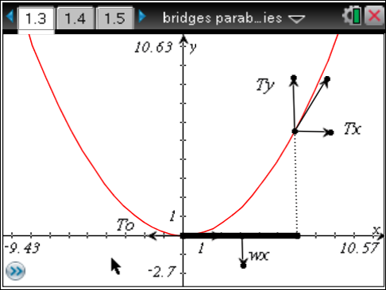
The diagram above shows a light (weightless) cable, the curve, supporting a heavy roadway, the x-axis. Part of the roadway is shown in bold. Now imagine the tension action on the section of the cable from the origin to the point on the curve vertically above the right hand end of the bold section. Remember the tension must lie along a tangent to the cable at all points, and the tangent is the gradient of the curve.
T₀ is horizontal and must be balanced by T_{X} . It is a constant because the vertical weight of the roadway does not add any horizontal component to the tension. T_{Y} is vertical and must be balanced by the weight of the bold section of roadway. If the weight of the roadway is w/ unit length
T_{Y} = wx
T_{O} = T_{X}
The gradient of the curve is T_{Y}/T_{X} = wx/T_{O}
=(w/T_{O})x
W and T_{O} are constants therefore the gradient is proportional to x. Students can experiment with the quadratic function (vertex at the origin) and find out that the gradient doubles as x doubles, that is the gradient is proportional to x. Our analysis of the tension in the cables shows that the gradient is proportional to x and so the curve is a parabola. The scientific model is the force diagram. The mathematical model is the parabola. The two models complement each other and allow the engineer to make predictions. For example, how far apart should the pillars be and what sort of tension is necessary. How thick must the cables be so that they do not snap and then of course if the cables have weight how will the model change?

Now if there is no roadway we will dispense with the weightless chain and give the chain itself some weight, s per unit length of chain. In this case if the length of chain in question is L
T_{Y} = sL
T_{O} = T_{X} again.
Now the gradient, dy/dx, = sL/T₀
This means that the rate at which the weight is changing is proportional to the weight itself and so we would expect the function which fits the cable to be some sort of exponential function.
There is a function known as hyperbolic cosine (cosh) which is half the sum of two exponentials.
cosh(x) = [ex + e-x]/2
The equation of a catenary moving up and down the y-axis is
y= acosh(x/a)+b
Sliders will be automatically fitted to the function so that we can fit a catenary function to a hanging chain, here a necklace of two different lengths.
