Volumes of prisms [Answers are at the end of this unit]
This unit uses the idea that the volume of a shape can be worked out from the fact that V = Ah, where A is cross sectional area of a shape and h is the length.
This unit requires the use of the formula A = $\frac{1}{2}absinC$ to work out the area of the front face.
Calculate the volume of each of the prisms shown below.
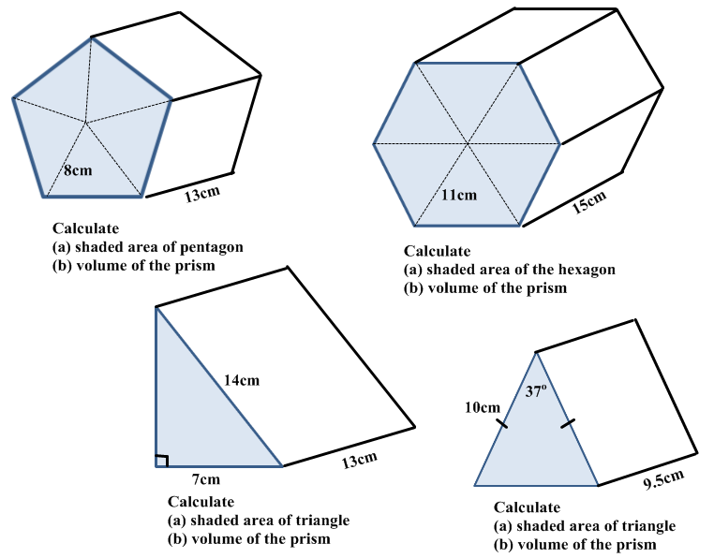
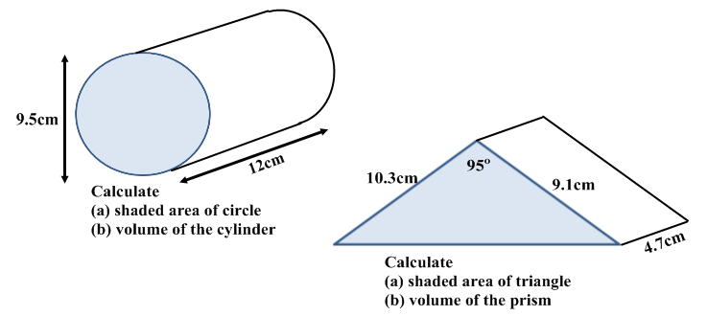
Calculate the volume of each of the prisms shown below.
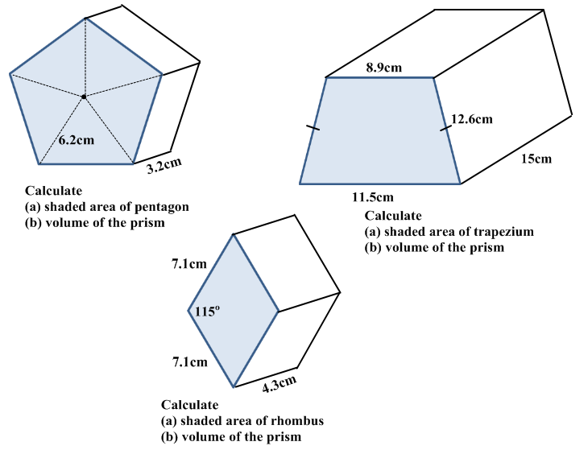
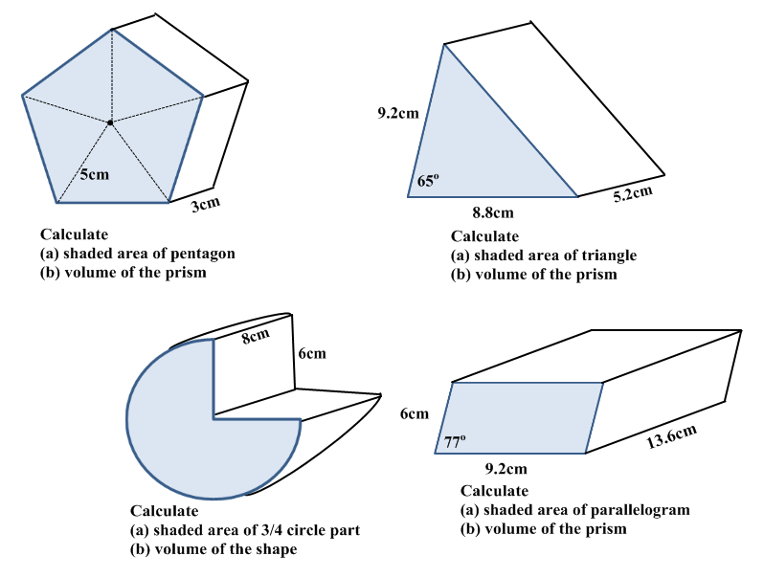
Calculate the volume of each of the prisms shown below.
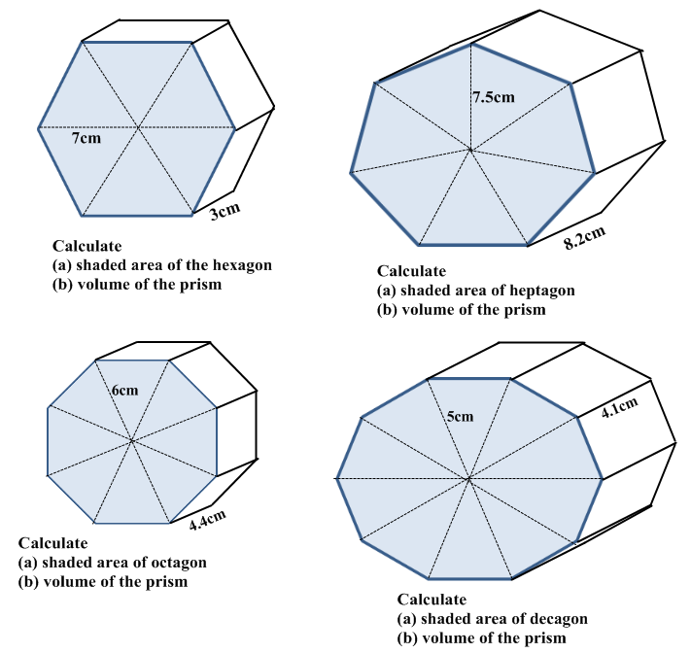
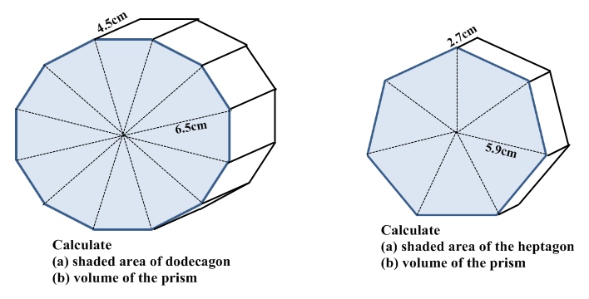
Calculate the volume of each of the prisms shown below.
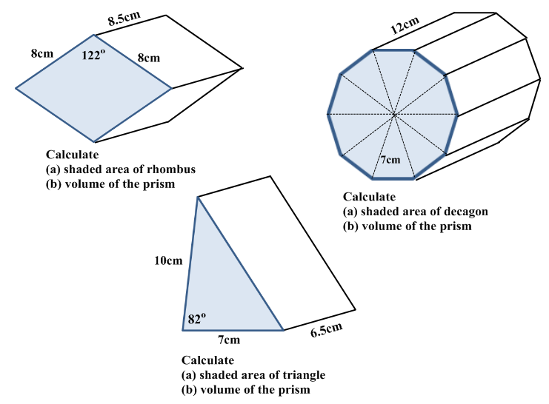

Answers
Page | Questions
1 | 1. (a) 152.2 (b) 1978.2 2. (a) 314.4 (b) 4715.5 3. (a) 42.4 (b) 551.7  4. (a) 30.1 (b) 285.9 5. (a) 70.9 (b) 850.6 6. (a) 46.7 (b) 219.4
2 | 1. (a) 91.4 (b) 292.5 2. (a) 127.5 (b) 1912.5 3. (a) 45.7 (b) 196.5  4. (a) 59.4 (b) 178.3 5. (a) 36.7 (b) 190.8 6. (a) 84.8 (b) 678.6  7. (a) 53.8 (b) 731.5
3 | 1. (a) 127.3 (b) 381.9 2. (a) 153.9 (b) 1262.2 3. (a) 101.8 (b) 448.0  4. (a) 73.5 (b) 301.1 5. (a) 126.8 (b) 570.4 6. (a) 95.3 (b) 257.2
4 | 1. (a) 54.3 (b) 461.3 2. (a) 144.0 (b) 1728.1 3. (a) 34.7 (b) 225.3

